1. Wireshark installed
2. Captured packets.
3. Ip header:

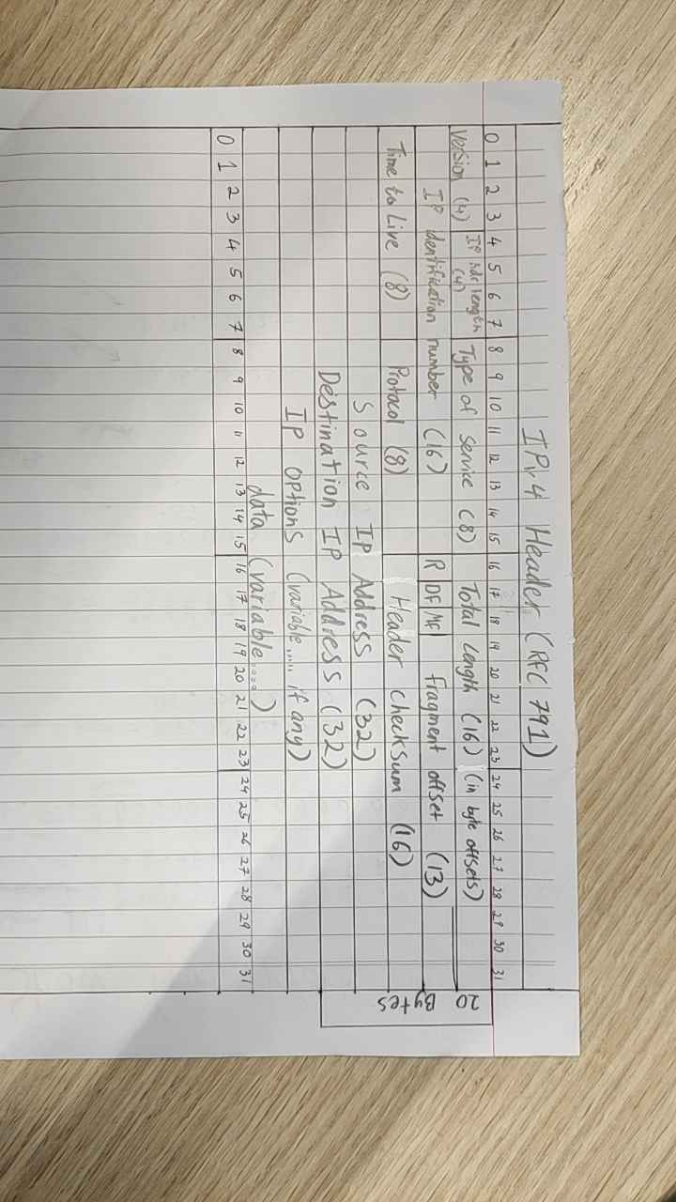

1. Explain fields:

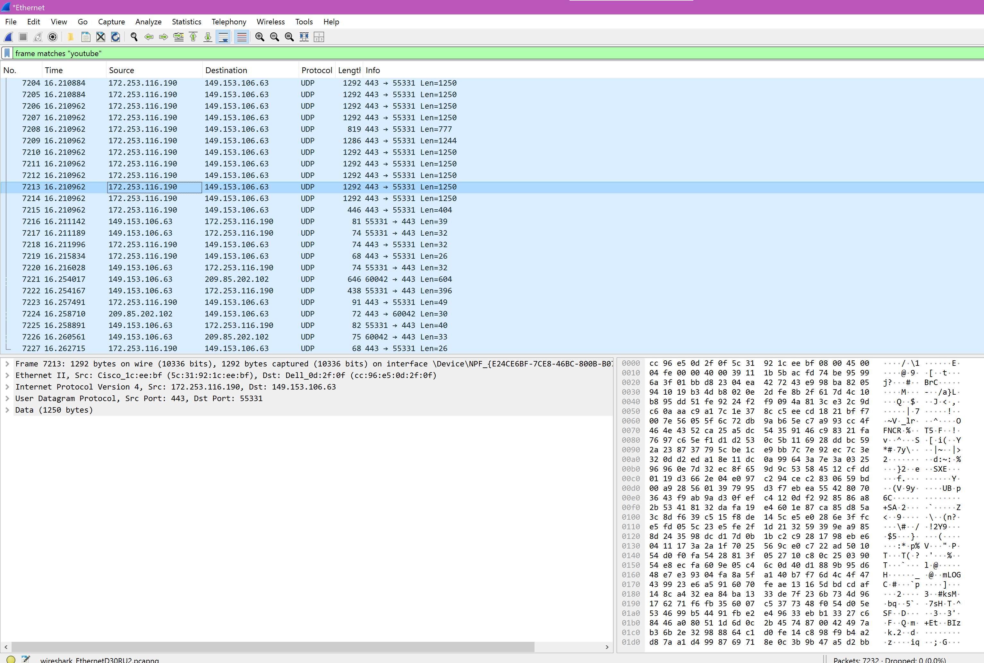

No. = Iteration of how many packets have been captured.

Time = How many seconds has passed since packet capture has started.

Source = The IP the packet originated from.

Destination = The IP the packet was sent to.

Protocol = The set of rules for sending and receiving data packets across network.

Length = Refers to size of the IP packet in bytes including the header and data.

Info = Provides a quick summary of the packet contents such as protocol, port numbers, data lengths

6.

Skyrim:

- Weather and Day/Night:

- Changes over time (snow, rain, etc.)

- Day and night affect how the world looks and how characters act

- Big Open World:

- Huge map with lots of places to explore (mountains, forests, cities)

- Always something new to find

- Role-Playing:

- Create and customize your character (choose race, skills, etc.)

- Your choices affect the story and how people treat you

- Level up by using your skills (fighting, magic, etc.)

Factorio:

- Automation:

- Build factories that automatically produce items

- Set up machines to gather resources, craft products, and transport them

- Resource Management:

-Mine resources like iron, copper, and coal

- Balance energy, production, and logistics to keep things running smoothly

- Big Open World:

- Explore a large, randomly generated map

- Find new resources, deal with alien creatures, and expand your factory

- Tech Progression:

- Research new technologies to unlock advanced machines and upgrades

- Start simple and gradually build complex production chains

Minecraft:

- Crafting and Building:

- Collect materials to craft tools, weapons, and items

- Build anything you want using blocks (houses, castles, farms)

- Exploration:

- Explore randomly generated worlds with forests, caves, oceans, and more

- Find rare resources, hidden dungeons, and different biomes

- Big Open World:

- Infinite, randomly generated landscapes to explore and shape

- Different biomes with their own resources, animals, and challenges

- Survival:

- Gather resources, manage hunger, and stay safe from monsters (like zombies, creepers)

- Craft better gear to survive in more dangerous environments

7.

- YouTube

- Amazon

- Spotify

- Discord

- Instagram

- Netflix

- Audible

- Steam

- Photopea

- OBS

- Crunchyroll

- PayPal

- Google pay

- eBay

- Shein

- Just eat

- Duolingo

- Figma

- Whatsapp

- Snapchat